ENTERPRISE NETWORK LAB
Redundant Multi-Site Routing, Switching, Security & Services
Designed and built in PNETLab
Boby Shelton Lambert | CCNA

1. Project Overview
This lab simulates a redundant enterprise network with Headquarters, Branch, and Data Center environments. The design combines Layer 2 and Layer 3 redundancy, dynamic routing, BGP edge connectivity, centralized DHCP, firewall segmentation, and dual Internet paths. The project was built to practice enterprise-style troubleshooting and failure testing rather than only basic device configuration.

2. Technologies Implemented
- OSPF for HQ/Data Center routing and EIGRP for Branch routing
- BGP between the enterprise edge and two simulated ISPs
- HSRP for redundant default gateways
- EtherChannel/LACP and Spanning Tree for Layer 2 resiliency
- Centralized DHCP with an Alpine Linux DHCP server and Cisco IP helper-address
- pfSense firewall for Data Center server/DMZ segmentation
- Static and floating/default routing for simple Internet link redundancy
- VLANs, SVIs, trunking, inter-VLAN routing, and routed transit links
- End-to-end connectivity, route verification, and failure testing

3. High-Level Topology
The enterprise contains two Core switches, two Edge routers, two ISP paths, redundant multilayer switches at the sites, access switches, a pfSense firewall, and centralized server services.
Area | Main Components | Purpose
Internet Edge | EDGE1, EDGE2, ISP1, ISP2 | External BGP and redundant Internet connectivity
Core | CORE1, CORE2 | Enterprise backbone and route redistribution
HQ | Two L3 switches + access layer | OSPF, HSRP, VLAN gateway redundancy
Branch | MSW3, MSW4 + access layer | EIGRP, HSRP, VLAN gateway redundancy
Data Center | DC L3 switches, pfSense, Server/DMZ access | Server connectivity, firewalling, segmentation

4. Addressing Summary
Network | Purpose
10.10.x.0/24 | HQ VLAN networks
10.20.x.0/24 | Branch VLAN networks
10.30.50.0/24 | Data Center server network
10.30.60.0/24 | DMZ network
10.255.x.x | Enterprise routed/transit infrastructure
172.16.x.x | Additional core/transit routing links

5. Centralized DHCP
A single Alpine Linux server provides DHCP for multiple sites. The server uses the static address 10.30.50.10/24 with default gateway 10.30.50.1. Remote VLAN SVIs use ip helper-address 10.30.50.10 to relay client DHCP broadcasts to the centralized server.
Site/VLAN | Subnet | Lease Range | Gateway
DC Server | 10.30.50.0/24 | 10.30.50.100-150 | 10.30.50.1
HQ VLAN10 | 10.10.10.0/24 | 10.10.10.100-150 | 10.10.10.1
HQ VLAN20 | 10.10.20.0/24 | 10.10.20.100-150 | 10.10.20.1
HQ VLAN30 | 10.10.30.0/24 | 10.10.30.100-150 | 10.10.30.1
Branch VLAN10 | 10.20.10.0/24 | 10.20.10.100-150 | 10.20.10.1
Branch VLAN20 | 10.20.20.0/24 | 10.20.20.100-150 | 10.20.20.1
Branch VLAN30 | 10.20.30.0/24 | 10.20.30.100-150 | 10.20.30.1

6. Routing Design

OSPF
OSPF provides dynamic routing for the HQ/Data Center portions of the lab and carries enterprise routes toward the core. User VLAN interfaces are advertised as passive interfaces so their subnets are reachable without attempting OSPF adjacencies with end devices.

EIGRP
The Branch uses EIGRP AS 100 toward the core. Redundant EIGRP paths were tested by shutting one routed uplink and confirming that the alternate neighbor/path remained available.

BGP / Internet Edge
The Edge layer uses BGP with simulated ISPs. EDGE1 connects to ISP1 through 203.0.113.0/30 and EDGE2 connects to ISP2 through 192.151.100.0/30. Internal BGP connectivity is also used within AS 65000.

7. First-Hop and Layer 2 Redundancy
HSRP provides resilient virtual gateways for user VLANs. For example, Branch VLANs use virtual gateways 10.20.10.1, 10.20.20.1, and 10.20.30.1. Different switches can be active for different VLANs to distribute traffic.
EtherChannel/LACP bundles redundant switch links. During testing, one physical member was shut while the port-channel remained operational through the remaining member. Spanning Tree was also verified to maintain loop-free forwarding.

8. Data Center and Firewall
pfSense separates the routed Data Center infrastructure from server and DMZ networks. The server-facing interface uses 10.30.50.1/24 and the DMZ-facing interface uses 10.30.60.1/24. The Data Center transit includes the 10.30.254.4/30 network.

9. Redundancy and Failure Tests
Test | Action | Result
HSRP failover | Shut the active Branch VLAN20 SVI | Standby multilayer switch transitioned to Active
EtherChannel member failure | Shut one LACP member link | Port-channel remained up through the second member
EIGRP/Core path failure | Shut one Branch routed uplink | Alternate EIGRP path remained available
ISP/Edge link redundancy | Shut the CORE1-to-EDGE1 link | Traffic used the alternate CORE2/EDGE2/ISP2 path
Internet verification | Ping 8.8.8.8 during backup operation | 100% successful during tested failover state

10. Troubleshooting Performed
- Resolved missing OSPF advertisements that prevented return routing to HQ VLANs.
- Corrected missing DHCP helper addresses and validated centralized DHCP across HQ and Branch.
- Fixed an EtherChannel mismatch where one member was configured as an access port while the bundle required trunking.
- Resolved HSRP and VLAN forwarding issues and verified gateway takeover during failure.
- Diagnosed Internet return-path routing and added the required upstream route for the Data Center server subnet.
- Validated alternate Internet routing when the primary Core-to-Edge link was unavailable.

11. Useful Verification Commands
show ip interface brief
show ip route
show ip ospf neighbor
show ip eigrp neighbors
show ip bgp summary
show standby brief
show etherchannel summary
show spanning-tree vlan <vlan-id>
show interfaces trunk
ping <destination>
traceroute <destination>

12. Skills Demonstrated
This project demonstrates hands-on configuration and troubleshooting of Cisco routing and switching, multi-protocol routing, gateway and link redundancy, BGP edge connectivity, centralized network services, firewall segmentation, and structured failure testing. The lab also required tracing asymmetric/incorrect routing behavior and correcting configuration mismatches across multiple network layers.

13. Portfolio Screenshot Checklist
- Full PNETLab topology
- HSRP status showing Active/Standby gateways
- OSPF and EIGRP neighbor tables
- BGP summary on both Edge routers
- DHCP client receiving an address from the centralized server
- EtherChannel summary showing bundled member links
- pfSense interface/addressing view
- Successful end-to-end ping between sites
- Successful Internet ping during a backup-link test
- Routing table showing the alternate default path during failover

14. Project Summary
The final lab provides a practical enterprise-style environment rather than a single-protocol exercise. It combines redundant switching, first-hop redundancy, multiple dynamic routing protocols, BGP Internet connectivity, centralized DHCP, firewall segmentation, and failure testing. The most valuable part of the project was troubleshooting realistic issues such as missing routes, trunk/EtherChannel mismatches, DHCP relay problems, and redundant-path behavior.

15. Verification Evidence
The following screenshots were captured directly from the working PNETLab environment. They provide visual evidence of the topology, dynamic routing, centralized DHCP, and end-to-end connectivity.

15.1 Final PNETLab Topology
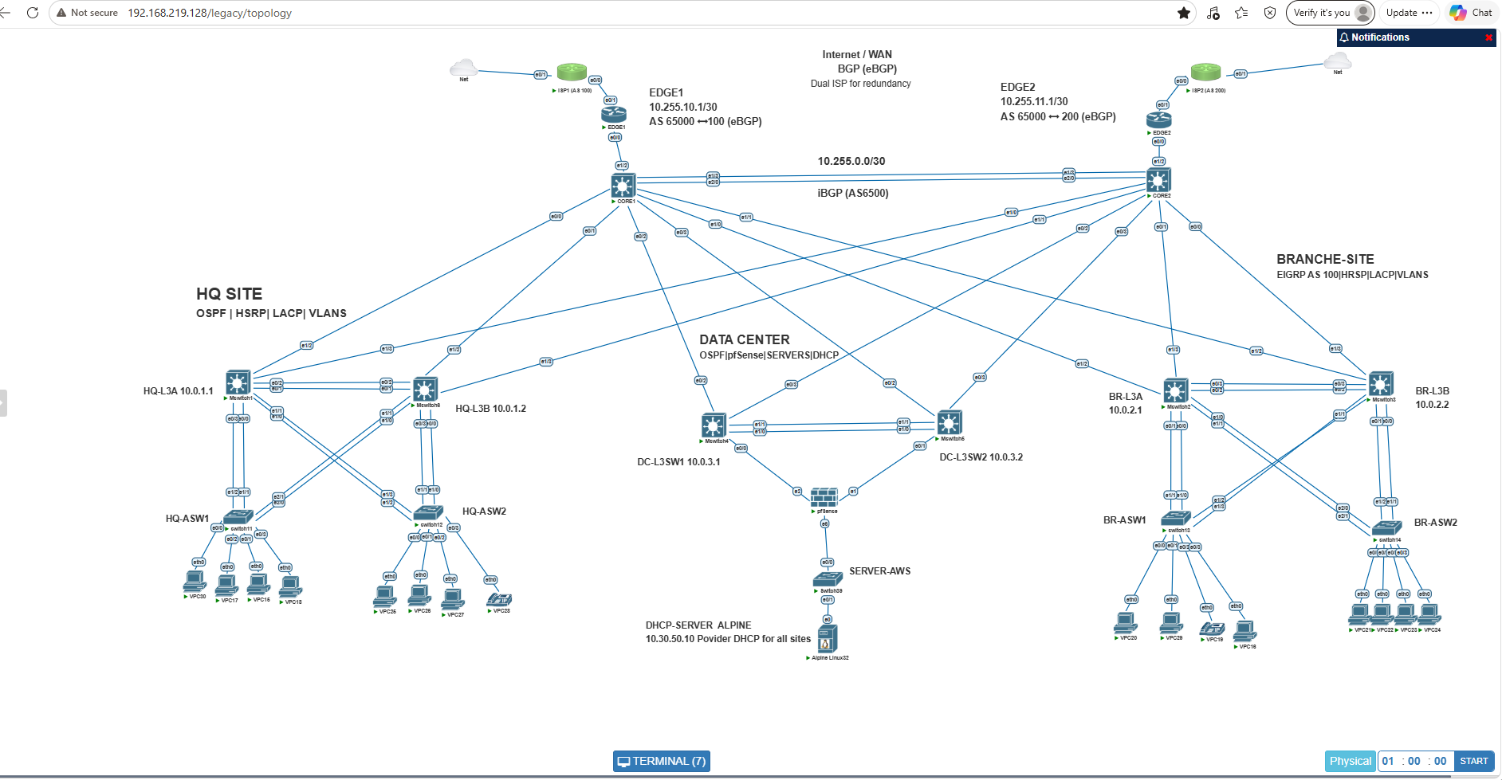
Figure 1. Final multi-site PNETLab topology with Internet/WAN, HQ, Data Center, Branch, routing protocols, firewall, and centralized DHCP labels.

15.2 OSPF Neighbor Verification
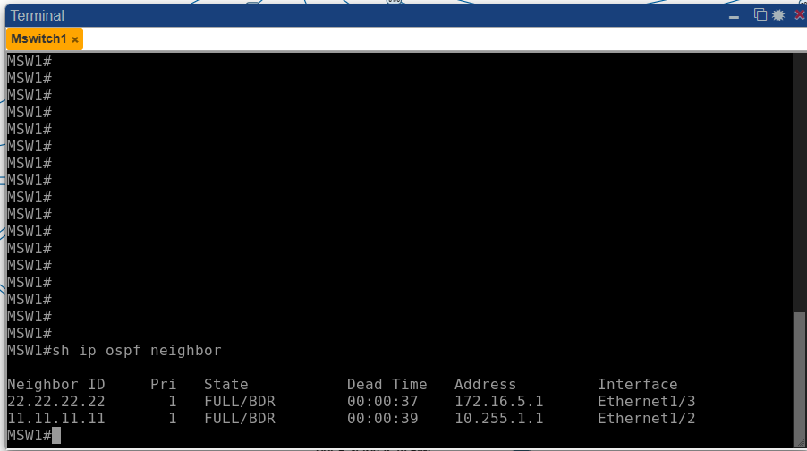
Figure 2. HQ multilayer switch maintains FULL OSPF adjacencies toward both core paths.

15.3 OSPF Learned Routes and Redundant Paths
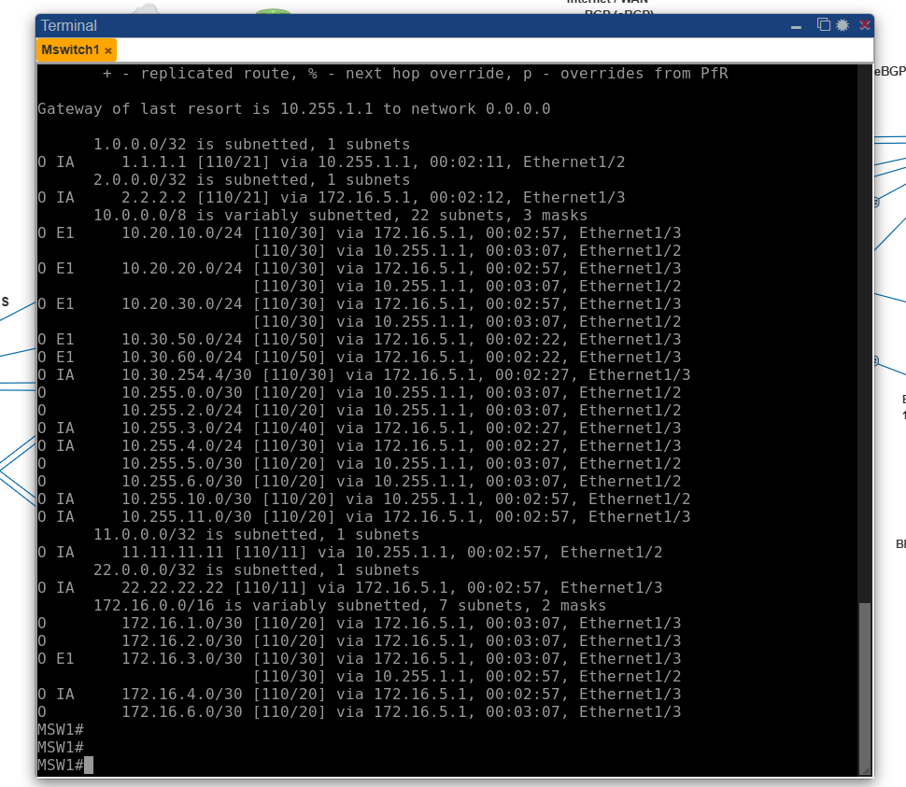
Figure 3. OSPF routing table showing learned enterprise networks and multiple next-hop paths.

15.4 EIGRP Learned Routes and Redundant Paths
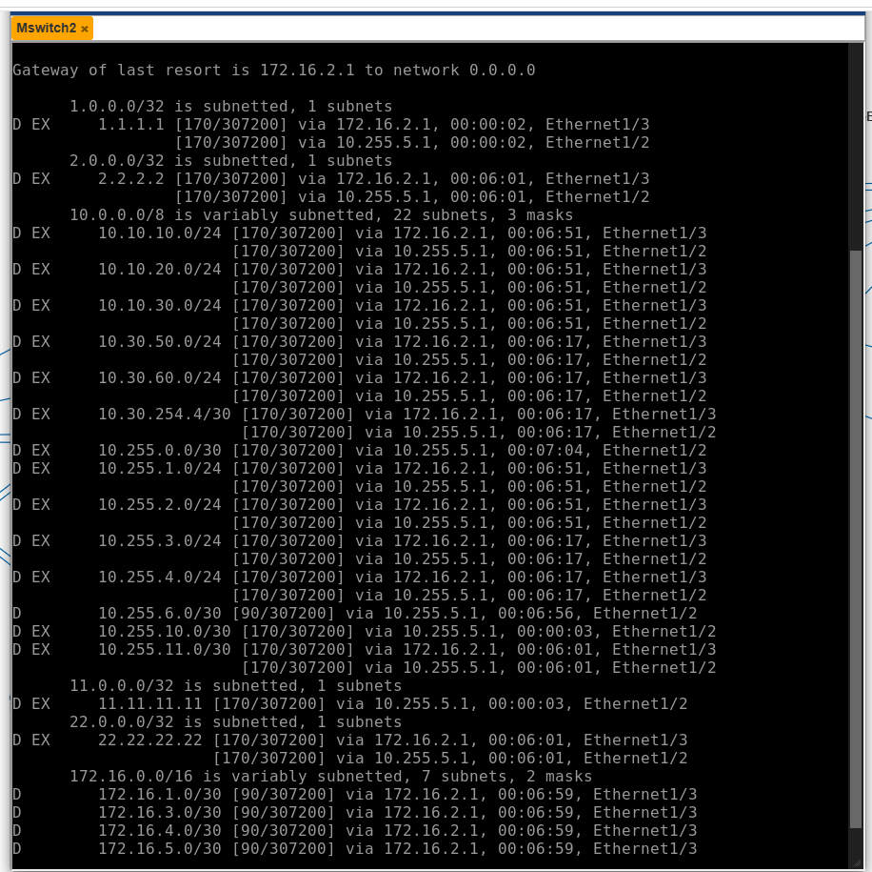
Figure 4. Branch EIGRP routing table showing internal/external EIGRP routes and redundant next hops toward the core.

15.5 BGP Verification - EDGE2
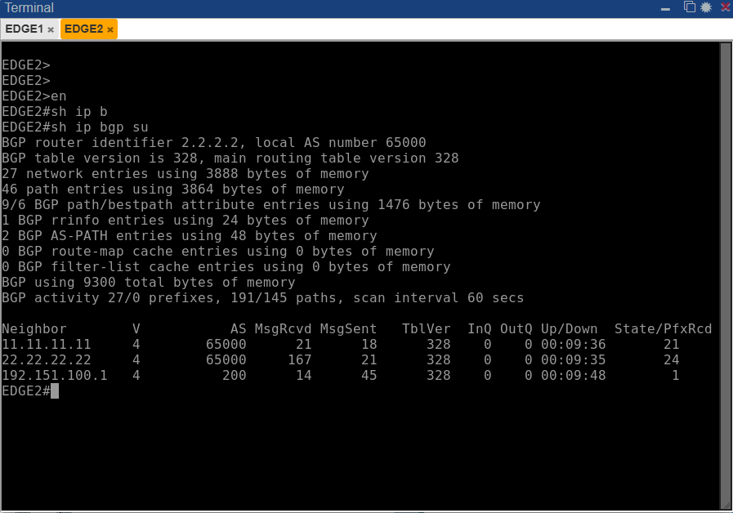
Figure 5. EDGE2 BGP summary showing established internal AS 65000 peers and eBGP connectivity to ISP2 (AS 200).

15.6 Centralized DHCP Verification
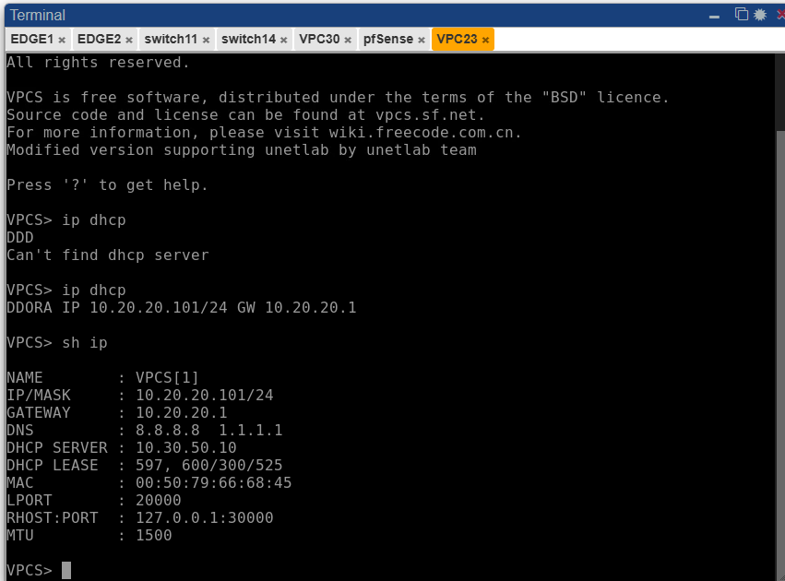
Figure 6. Branch client receives 10.20.20.101/24, gateway 10.20.20.1, DNS servers, and a lease from the centralized DHCP server at 10.30.50.10.

15.7 End-to-End Connectivity Verification
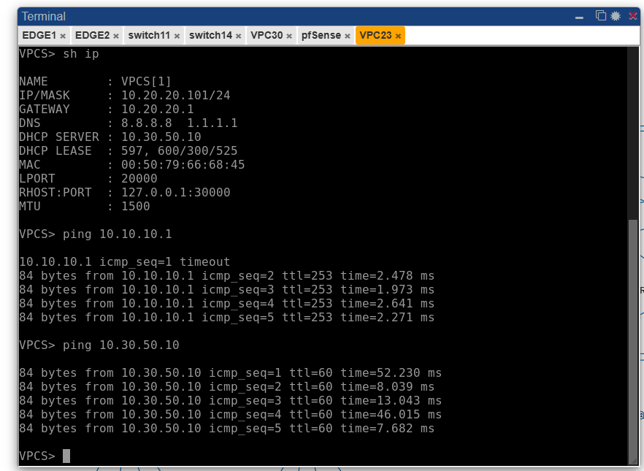
Figure 7. Branch client reaches the HQ gateway (10.10.10.1) and the Data Center DHCP server (10.30.50.10), demonstrating inter-site connectivity.

16. Evidence Still Recommended for the Repository
The core portfolio document is complete with the screenshots available in this conversation. For the GitHub repository, retain the additional screenshots already captured during testing: HSRP status, EIGRP neighbors, EDGE1 BGP summary, EtherChannel summary, STP VLAN 10 status, and the final Internet/failover ping. These can be stored in a screenshots/ folder without making the main document overly long.

17. Portfolio Description
Built and troubleshot a redundant multi-site enterprise network in PNETLab using Cisco routing and switching, OSPF, EIGRP, BGP, HSRP, EtherChannel, STP, centralized DHCP, and pfSense. Verified redundant routing paths, gateway failover, link resiliency, cross-site connectivity, and Internet access while troubleshooting routing, DHCP relay, trunking, and EtherChannel configuration issues.

